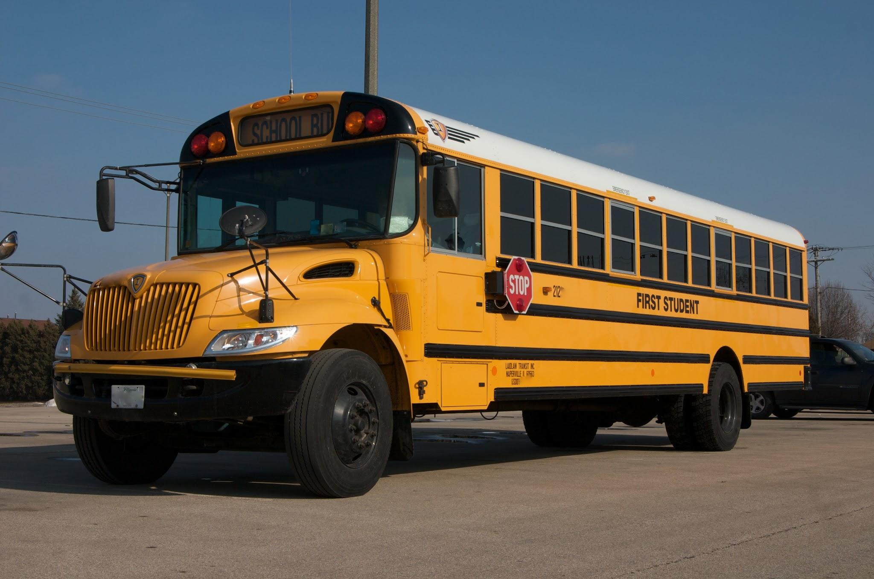
Herget 5:15PM Activity Bus
Monday-Friday

BUS 80
- Indian Trail @ Courtyard
- Illinois Ave @ Pennsylvania(Hill)
- Konen Ave @ Arlene
- Chesterfield @ Pine Creek
- Comiskey Ave @ Ritter

BUS 48
- Prestbury Club House
- Meade @ Bauer
- Schneider School

